What should I do with used paint?
Not sure what to do with old paint? Here are some tips to condense or dispose of your surplus!

Determine if the paint is still usable
Solvent-based paints have a 15-year shelf life. If you can stir it, it’s probably okay to use (even if you have to remove the “skin” on the surface first). Latex has a shelf life of 10
years. If it has been subject to freezing, it may not be usable. Test by stirring and brushing onto newspaper. If there are lumps, the paint is no longer usable.

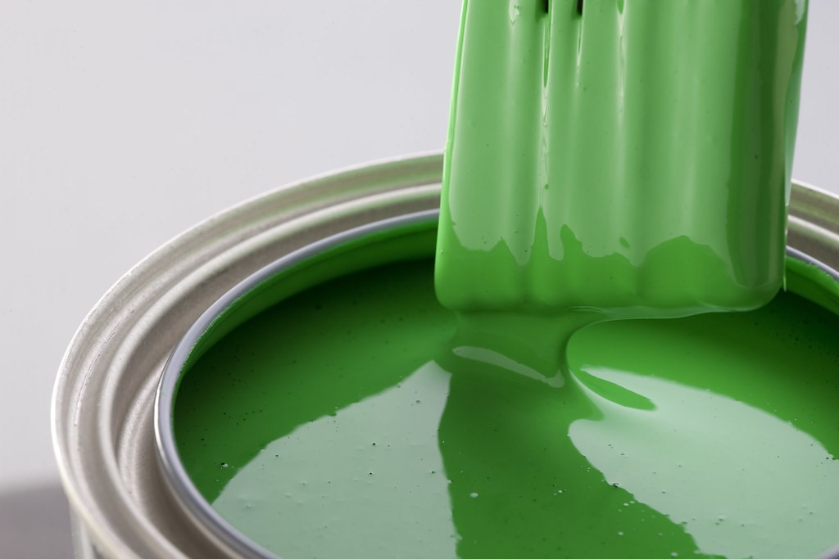

Look for ways to use the leftovers
Even if you’re sure the paint color is not one you’ll return to, consider mixing leftovers of the same paint type (latex with latex, acrylic with acrylic, oil with oil) to use as an undercoat primer.

Donate paints you don’t want
If you have good paint that you can’t use, offer it to family, friends and neighbors, or call a local paint contractor. Some charities such as Habitat for Humanities may accept paint donations.

Dispose of what you can’t use and can’t give away
How you do it depends upon the type of paint, but it’s critical that it be done in a manner that won’t cause pollution to drinking water or waterways. One gallon of paint can contaminate many thousands of gallons of water, harm fish and aquatic plant life, and eventually poison the food chain.

The proper ways to dispose of paint:

Latex and acrylic paints
Many municipalities will allow you to solidify these paints and throw them away with the household trash. One way to do this is to mix it with a clay-based cat litter at a ratio of two parts litter to one part paint. Do this in a well-ventilated place. Another way is to use an additive to harden the paint. These additives are sold in many hardware stores and on line. Another way to harden paint is kitty litter.

Oil-based and alkyd paints
Check to see if there is a scheduled house-hold hazardous waste collection day in your community. If your community does not offer this service, call your County Extension Home Economics Agent, the local waste management agency, your area’s water treat-ment plant or the local landfill, and ask
what the procedure is for where you live. You can also use an additive to harden the paint and dispose of the harden paint in your trash.


Contact the Montana Department of Environmental Quality’s Materials Management Program: Dusti Johnson (406) 444-6499 dujohnson@mt.gov
For more information about our programs please visit our website at https://deq.mt.gov/twr/programs/ recycling

